**Lost & Found System**

Project Proposal

­­­

By

**Miss. Phannida Panyasit 532115062**

**Mr. Supavas Sitthithanasakul 532115093**

Department of Software Engineering

College of Arts, Media and Technology

Chiang Mai University

Project Advisor

________________________

**Mr.Kittitouch Suteeca**

|  |  |  |  |  |  |  |
| --- | --- | --- | --- | --- | --- | --- |
| **Document Name** | **Version** | **Status** | **Date** | **Viewable** | **Reviewer** | **Responsible** |
| **Documents** | | | | | | |
| Lost & Found- Project Proposal_V.0.1.docx | - Add Chapter1  - Introduction & Background  - Add Chapter2  - Business Review  - Business Tools  - Software review  - Technology Review  - Development Tool Review  - Add Chapter3  - Quality Standards  - Add Chapter4  - Project Plan  -Add Chapter5  - References | Draft | 10-02-2013 | PP, SS, KS | PP, SS | PP, SS |
| Lost & Found- Project Proposal_V.0.2.docx | - Adjust Project Name  - Adjust Abstract  - Adjust Chapter2  - Business tools  - Adjust Chapter5  - References  - Change font and font size | Draft | 02-03-2013 | PP, SS, KS | PP, SS | PP, SS |
| Lost & Found- Project Proposal_V.1.0.docx | - Technology Review  - Schedule & Milestone review | Released | 06-03-2013 | PP, SS, KS | PP, SS | PP, SS |
| Lost& Found- Project Proposal_V.1.1.docx | - Edit limitation  - Fix inappropriate word | Reviewed | 30-03-2013 | PP, SS, KS | PP, SS | PP, SS |
| Lost& Found- Project Proposal_V.2.0.docx | - Fix inappropriate word | Released | 29-09-2013 | PP, SS, KS | PP, SS | PP, SS |
| Lost& Found- Project Proposal_V.3.0.docx | - Fix constraint and limitation | Released | 03-10-2013 | PP, SS, KS | PP, SS | PP, SS |

**Document History**

**\*PP = PhannidaPanyasit**

**\*SS = Supavas Sitthithanasakul**

**\*KS = Kittitouch Suteeca**

**Abstract**

As people live today, their properties may disappear, or they found properties frequently. An alternative way to help owner meet their properties or to help good citizens can track down the owner quickly and conveniently. Also, they can widely spread the information to other people who may help to track or to provide clues. A new system should be developed. For this project, "Lost & found system" is created. This system will provide user post to find lost properties or to track the owner, to search and share posts to the social network. With this system, it is allow the user to manage their post and also to see all location of properties, which lost or found in a map. Moreover, this system have a crime reporting to tell the user where areas have the high rate in losing properties and a reward board for announce who are good citizens that track the owner and return properties to the actual owner. Then an attempt is made a charity system for donating the item which unclaimed and did not find the owner.

**Table of contents**

Chapter One | Introduction and Background 5

Chapter Two | Literature Review 6

2.1 Business Review 6

2.2 Business Tools and Software Review 7

2.3 Technology Review 9

2.4 Development Tool Review 13

Chapter Three |Quality Standard 16

3.1 ISO29110 for Very Small Entity (VSE) 16

3.1.1 Project Management process 16

3.1.2 Software Implementation process 16

Chapter Four | Project Plan 17

4.1 Motivation 17

4.2 Aims and Objectives 17

4.3 Deliverables and Limits 18

4.3.1Deliverables 18

4.3.2 Limits 19

4.4 Schedule & Milestones 19

Chapter Five | References 24

# **Chapter One | Introduction and Background**

Formerly, there are manyproblems about peoplewholost their properties. Thesethings can occuranywhereand anytime whilethey are not awareorcareful to their properties. Whenthesesituationshappen, most of them may try to findsomesolution to get their propertiesreturned. Thepopularwaysthatalmostpeople may use in thissituation are report to thepolice, asks someone around lostpropertylocationorpublish by a poster. By theseways, iftheyluckyenough, they may have their propertiesreturnedbecausethechance to getlostitemback is verylow since they cannot knowthatpolice will help them findtheitemor not, may be someone may foundthelostitemsbut not knowwho is theownerandhowthey can returnit to therightperson.

Nowadays, there are many technologies andtoolsdevelopedformanypurposes. Sothepeoplewholost their properties may usethese technologies to find its. The technology thatverypopularandfastforpublishesanyinformation is known as “Social Network”. With this, they can post information about lostpropertiesandshareit to public. When their friendsseethispost, they may shareit to morepeople to helptheproperty’s owner; wecallthis as a “Chain share”. Thissolution may be a goodway to findmissingthing, but there is one importantproblem that alwayshappens with everypost. Theproblem is they cannot control their post anymore after shareit to public. Because of otherpeople cannot knowthattheownersalreadyget their propertiesback, or not. Sothepost will continuesharedandbecomechainshare at last.

With theseproblems, our groupdecides to createthe Lost & Found System to solveallpreviousproblems. By creating as a webboard with consists with reportfunction, locationbasesystem, socialnetworksharingandnotificationalert. Themainobjective of thissystem is to findthelostpropertiesforreturn to theactualowners. Wehopefullythatthissystemandallfunctionimplemented will solvethelostpropertyproblem.

# **Chapter Two |Literature Review**

## Business Review

**Overview**

Lost & Found system is a web application that derived by JSP, HTML5 and CSS3. It is a web that created for helping people who lost their properties as an alternative way to find their properties. Then, it can help people to track the actual owner who lost properties.

**Target**

The main target of Lost & Found system is to manage the properties that disappear or found and provide an alternative way to return the properties to an actual owner.

**Benefit**

* User gets convenient.
* User has a choice to find their lost properties.
* User has a choice to track actual owner who lost the properties.

## Business Tools and Software Review

## Lostandfound.com

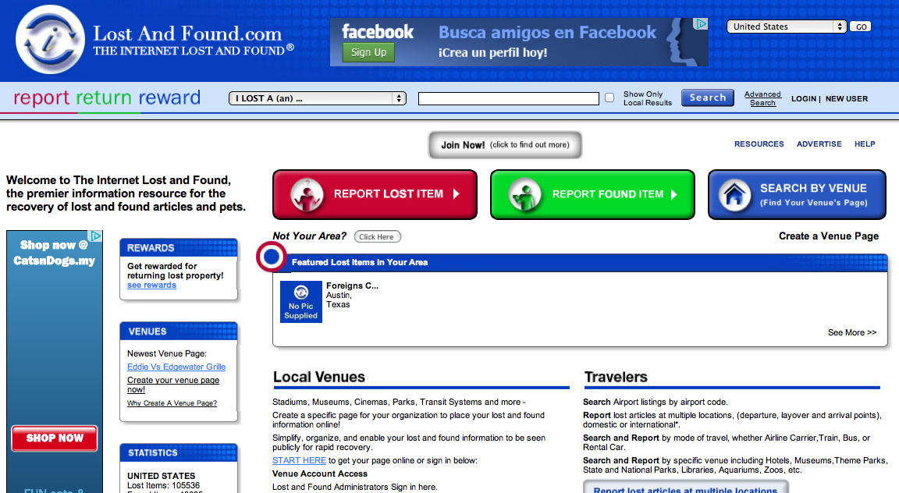

**Figure 2.1Lostandfound.com Review**

## Software Description

This web site offers a convenient feature for the user, it used for the exchange of lost and found information including the comprehensive online database of lost and found pet and any property, photos, resources, advice, and support tools, on the Internet. LostAndFound.com offers this information on a localized, national and worldwide basis. It provides a variety of categories and services that aim to help users with the necessary functions for the effective communication about lost and found the information.

Pros

* Have many features for support user.
* Full of information and details provided for user.
* Support many categories of item.

## Cons

* Full of text may make user confuse to use in some feature.
* No map that shows all location of lost and found item.

## Lostandfoundpets.ie

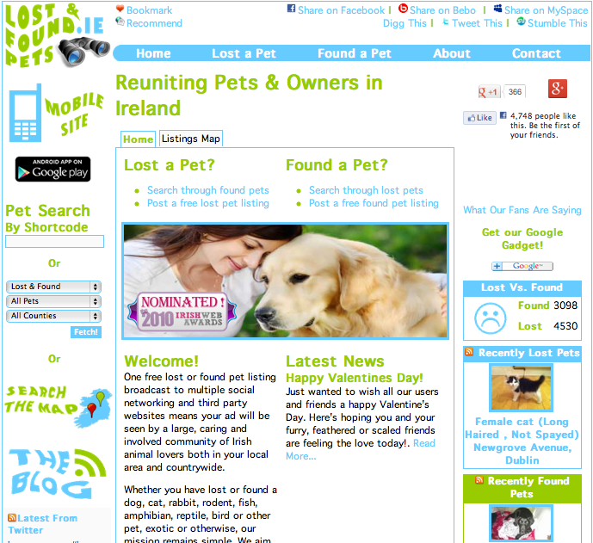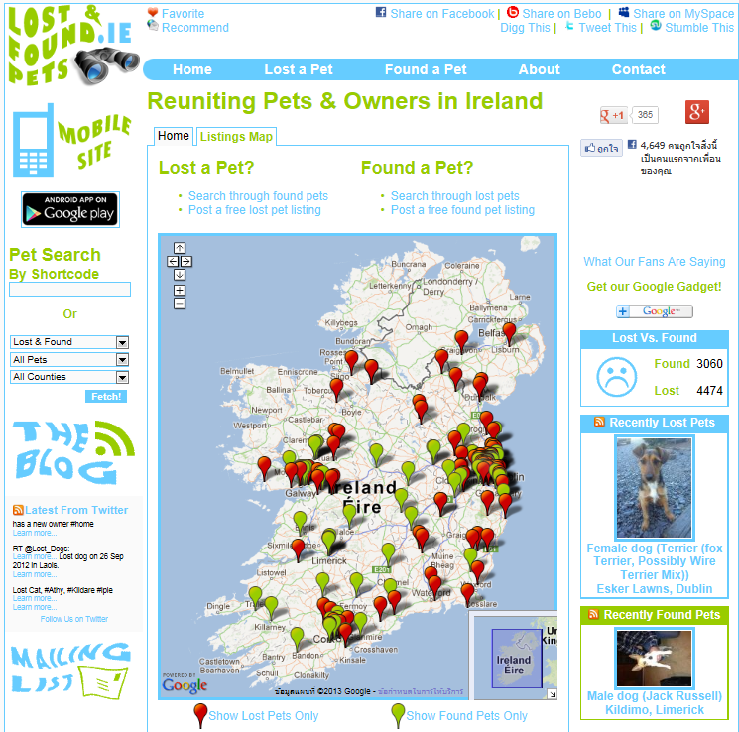

**Figure 2.2lostandfoundpets.ie Review**

## Software Description

This website is the Irish website that dedicated to losing and found pets. The aims are to return lost or missing Irish pets to their owners as simple and quick as possible. By use the feature of the Internet and social networking.

## Pros

* Each feature is easy to understand and use.
* User can view the map display all location of lost and found items.
* Support using this web site on mobile.
* Support many social networks.
* Has date management, which control; how lengthy day reports are posted and when it should be deleted from the system.

## Cons

* Support only pets that lost or found in Ireland.
* No login and membership required.

## Technology Review

## Spring Framework



**Figure 2.3 Spring Framework Review**

## Technology Detail

Spring is anopen source tool framework for supporting Java-based enterprise application development. This framework contains pattern and configuration for programming which can be deployed on any platform. It also supportsvariouscomponents to work together such as JDBC and Hibernate. Moreover, it can develop web application by use Java, JSP, HTML and XML together.

## Alternative Technology

* .NET Framework
* CakePHP

## The selection of this technology

* Support MVC pattern.
* Easy for unit testing.
* Support various components and technologies.

## Google Map API



**Figure 2.4 Google Map Review**

## Technology Detail

This API is a free service from Google. It enables users to embed Google Maps in their web pages and provide many services for customizing and adding content to the map.

## Alternative Technology

* Bing Map

## The selection of this technology

* Easy to implement, just call the API Service form Google.
* Provide necessary features for control map.

## Cascading Style Sheets (CSS)



**Figure 2.5 CSS Review**

## Technology Detail

CSS is stands for Cascading Style Sheets. It is defined how to display HTML elements that presentation of web pages, including colors, layout, and fonts.

## The selection of this technology

This project requirescreating as the web application. CSS make web application look better than only HTML does. It helps us design the web flexibility because we don’t need to define the style each tag. Then, redesign (i.e. colors, size, fonts) with not has effect to HTML code by create a separate CSS file for each page and only edit one single file.

## HTML5



**Figure 2.6 HTML5 Review**

## Technology Detail

HTML5 is the fifth revision of the HTML. It is a markup language to create a webpage and present contents that can be displayed in a web browser.

## Alternative Technology

* HTML older version.

## The selection of this technology

This project requires creating asthe web application. HTML5 makes creating accessible sites easier because <header>, <footer>, <nav>, <section>, <aside>, etc. allow other can access content easily than the older version. Then, HTML5 code is pretty clean and simple.

## Development Tool Review

## NetBeans



**Figure 2.7 NetBeans Review**

## Development Tool Description

NetBeans is software that provides programming support to the latest Java enhancements and the newest Java technologies before other IDEs. It supports for Java EE 6, JDK 7, and JavaFX 2.0. It's constantly improving Java Editor, provide many features and an extensive range of tools, templates and samples.

## Alternative Tool

* Eclipse
* IntelliJ IDEA

## The selection of this tool

* Netbeans is a free tool for any users no need license or contract.
* Provide many features necessary for MVC pattern development.
* Support tool from outside such as Google API and TomCat Server.

## MySQL Server



**Figure 2.8 MySQL Server Review**

## Development Tool Description

MySQL is an open source relational database management system which used by many users around the world. It can create both standalone and server database. It can integrate with other product such as MySQl Workbench, MySQL Notifier and MySQL Connector. It also supports many development tool for create a web application such as Eclipse, NetBeans.

## Alternative Tool

* Microsoft Access
* SQLite

## The selection of this tool

* Easy to integrate with development tool.
* Provide many features and security.
* Flexible for using and manage via other tool.

## Adobe Dreamweaver CS6



**Figure 2.9 Adobe Dreamweaver CS6 Review**

## Development Tool Description

Adobe Dreamweaver CS6 is the web design software that providesa visual interface for making and editing HTML websites.

## Alternative Tool

* Notepad++
* Coda2
* Sublime Text 2
* TextMate

## The selection of this tool

Adobe Dreamweaver CS6 has complete function that necessary to create website such as auto closes tags, code hinting, preview. It can split the code and design of the webpage at the same time.

# **Chapter Three| Quality Standard**

## 3.1 ISO29110 for Very Small Entity (VSE)

ISO29110 is a guide applies to a Very Small Entity (VSE), enterprise, organisation, department or project up to 25 people, dedicated to software development. The Guide provides Project Management and Software Implementation processes which integrate practices based on the selection of ISO/IEC 12207- *Systems and Software Engineering —Software Life Cycle Processes* and ISO/IEC 15289*Software Engineering – Software Life Cycle Process – guidelines for the content of software life cycle process information products (documentation)* standards elements.

### Project Management process

The purpose of the Project Management process is to establish and carry out in a systematic way the tasks of the software implementation project, which allows complying with the project’s objectives in the expected quality, time and cost.

**Activities**

* Project Planning Process
* Project Plan Execution Process
* Project Assessment and Control Process
* Project Closer Process

### Software Implementation process

The purpose of the Software Implementation process is the systematic performance of the analysis, design, construction, integration and tests activities for new or modified software products according to the specified requirements.

**Activities**

* Software Implementation Initiation Process
* Software Requirements Analysis Process
* Software Architectural Design Process
* Software Construction Process
* Software Integration and Test Process
* Software Delivery Process

# **Chapter Four | Project Plan**

## Motivation

Nowadays, many people have lost their properties in every place and every time. Someone finds some properties, and some are disappeared. There are many solutions to solve this problem such as a report to police, public information about lost property via newspaper, poster or others public relation. By the way, as the technology is growing every day, some people turn it as an advantage by use social network such as Facebook to help them solve the problem by sharing posts to their social network.

So we realize that using social network to share the post for find the lost properties or the owner of lost properties is easy and faster way to solve the problem, but the disadvantages about this way are each post will be shared from one person to many persons and then many persons to a large amount of persons on social network, we call this phenomenon as “chain share”. When it happens, we are unable to manage it anymore even if the lost properties are returned to owner already, the sharing still continues because the public not know about property’s status, they just continue to share it to help the property’s owner.

With these reasons, we think there must be some system to manage the problems, which can help the property’s owner and the person who found the property to meet each other. This system should still able to use social network for sharing but can be controlled and has more function to help solve these problems more easily, thereby resulting in “lost and found system”.

## Aims and Objectives

**4.2.1 Aims**

The aim of this project is to develop a web-base system that provide lost and found thing listing broadcast to multiple social networking, also to be a third party website that makes reuniting lost things with their owners as quick and easy as possible.

**4.2.2 Objectives**

* Alternative way to help owner finding lost properties and announcing found properties.
* Provide a graphic user interface to users that we can understand and easy to use.
* Increasing a chanceof the owner will meet their lost properties.
* Increasing a chanceof the lost properties will return to the actual owner.
* Provide multiple social networks to help user can share their post.
* After their post and share, information of post managed and controlled.

## Deliverables and Limits

### Deliverables

1) 1st progress

- Homepage, registration page and item report page

- Registration and login system

- Report lost item system

- Report found item system

2) 2nd progress

- Social network sharing

- Google map with all location of lost and found items

- Crime reporting

- Reward board

3) 3rd progress

- Notification alert to member’s e-mail

- Charity system

4) The document and other material

- Proposal

- Project plan

- Quality plan

- Software requirement specification

- Traceability record

- Software design document

- Testing document

* Test plan
* Unit test report
* System Test report

- 1 CD-ROM stores all source code; relate file, all documents and poster files in PDF format.

- 1 project poster

### Limits

* The application requires Internet connection to execute.
* Membership is required for using all function in the application.
* The main scope of application is used for reporting only.
* No guarantee that property will be returned to the actual owner.
* The application can work well on PC or laptop only because the system need higherperformance and bigger display screen than a mobile device.
* The application use only Chiang Mai map as a sample for developing and testing the system.
* The application allows the user to share each topic via social network but cannot manage the post after sharing to other system such as Facebook system or Twitter system.

## Schedule &Milestones

**Notation:**

Feature #1: Consists of user registration page, homepage and report page.

Feature #2: Consists of registration and login system.

Feature #3: Consists of lost item reporting system.

Feature #4: Consists of found item reporting system.

Feature #5: Consists of social network sharing system.

Feature #6: Consists of location base and map system.

Feature #7: Consists of crime reporting, reward board and other pages.

Feature #8: Consists of Notification alert system.

Feature #9: Consists of charity system.

**Schedule plan:**

Proposal phase: Create proposal document.

Progress I: Create Development plan, Quality plan, SRS, SDD and some part of Test document. Start creates feature# 1, 2, 3, 4 of system.

Progress II: Create feature# 5, 6, and 7 of the system, overall of the system should be higher than 70%. Continue on Test document.

Progress ShowPro: Create feature# 8, 9 of the system and integrate all features. Overall of the system should be complete or nearly. Continue on Test document.

Final progress: Integrate and review all document. Make sure all system and document are complete.

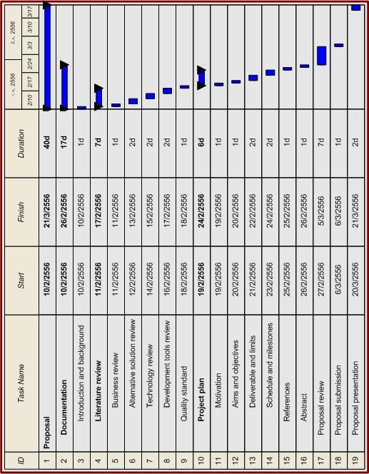

**Figure 4.1: Proposal Milestone**

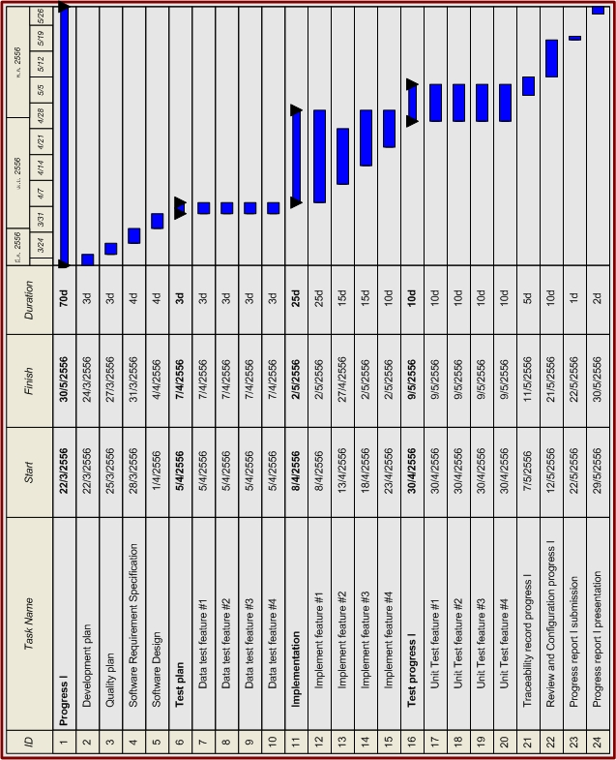

**Figure 4.2: Progress Report I Milestone**

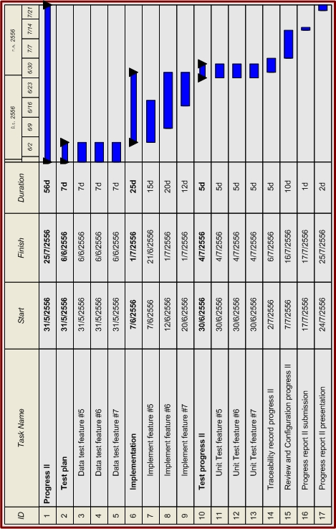

**Figure 4.3: Progress Report II Milestone**

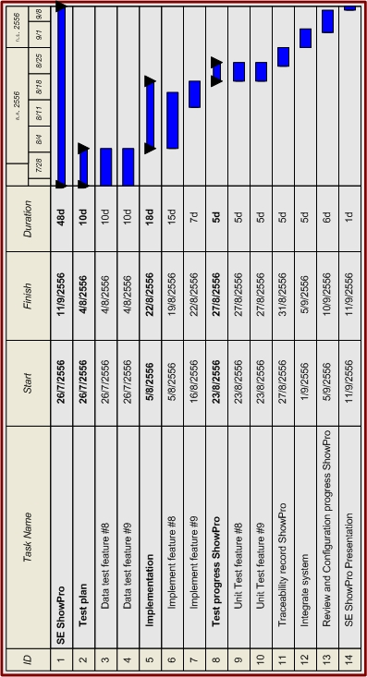

**Figure 4.4: Progress Report ShowPro Milestone**

# **C:\Users\WindnesS\Desktop\Application\Third year\Senior Project\Draft\Final progress.jpg**

**Figure 4.5: Final Progress Report Milestone**

# **Chapter Five | References**

[1]Adobe Dreamweaver CS6. Available from<http://www.adobe.com/products/dreamweaver.html>

[2] CSS. Available from<http://en.wikipedia.org/wiki/Cascading_Style_Sheets>

[3] Google Map. Available from<http://maps.google.com/help/maps/getmaps/advanced-options.html>

[4] HTML. Available from<http://en.wikipedia.org/wiki/HTML>

[5] HTML5. Available from<http://www.w3schools.com/html/html5_intro.asp>

[6] Lostandfound.com. Available from http://www.lostandfound.com

[7] Lostandfoundpets.ie. Available from http://www.lostandfoundpets.ie

[8] MySQL. Available fromhttp://en.wikipedia.org/wiki/MySQL

[9] Netbeans. Available fromhttp://netbeans.org/features/index.html

[10] Spring Framework. Available from http://www.springsource.org/spring-framework

[11] CSS3. Available from [Craig Cook](http://www.amazon.com/s/ref=ntt_athr_dp_sr_1?_encoding=UTF8&field-author=Craig%20Cook&search-alias=digital-text&sort=relevancerank) and [Jason Garber](http://www.amazon.com/s/ref=ntt_athr_dp_sr_2?_encoding=UTF8&field-author=Jason%20Garber&search-alias=digital-text&sort=relevancerank), Foundation HTML5 with CSS3 (New York: friendsofED, 2012), pp. 17-36

[12] MySQL. Available from [Larry Ullman](http://www.amazon.com/s/ref=ntt_athr_dp_sr_1?_encoding=UTF8&field-author=Larry%20Ullman&search-alias=books&sort=relevancerank), MySQL, Second Edition (San Francisco: Peachpit Press, 2006), pp. x-xiii